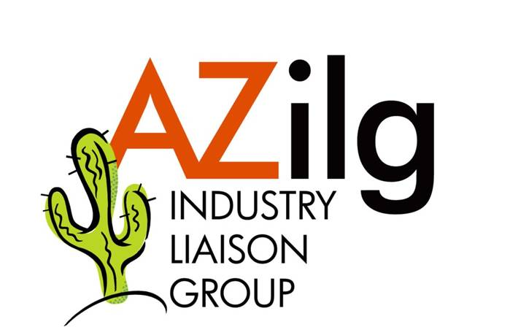

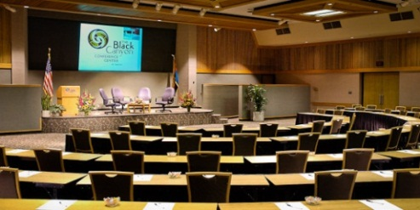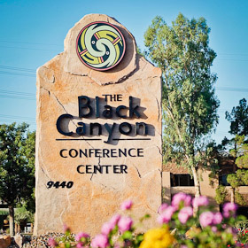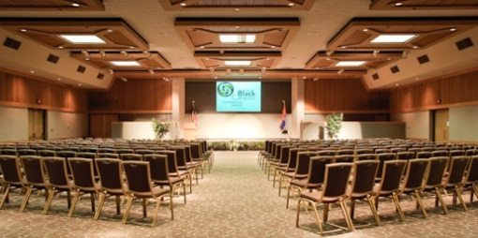

**15th Annual Compliance Conference**

The Black Canyon Conference Center

9440 N. 25th Avenue - Phoenix, AZ 85040 – November 15 & 16, 2012

[*http://www.blackcanyonconferencecenter.com*](http://www.blackcanyonconferencecenter.com)

**Pre-Conference (November 15, 2012)**

|  |  |  |  |
| --- | --- | --- | --- |
| **Start** | **End** | **Topic** | **Presenter(s)** |
| 7:00am | 7:45am | Registration | AZilg |
| 7:45am | 8:00am | Welcoming Remarks  This pre-conference workshop will focus on the theory and fundamentals of adverse impact and compensation analyses. The basics will be discussed and real-world examples from attendee organizations will be encouraged. Building off the basics; hands-on analyses will be conducted beginning with data preparation, and concluding with analyses conducted in Biddle Consulting Group’s proprietary software (demo versions to be provided to all attendees). This hands-on workshop is for all levels of EEO/AA practitioner. | John A Garza,  AZilg President |
| 8:00am | 9:00am | **AAP Basics** (Lecture) | Patrick M. Nooren, Ph.D.,  Executive Vice President, Biddle Consulting Group, Inc.,  Dan Kuang, Ph.D. Vice President - Legal and Audit Support Services, Biddle Consulting Group, Inc. |
| 9:00am | 10:00am | **Adverse Impact Analysis** (Lecture) |
| 10:00am | 10:15am | BREAK |
| 10:15am | 11:30am | **Adverse Impact Analysis** (Hands-On Workshop) |
| 11:30am | 12:30pm | LUNCH |
| 12:30pm | 1:45pm | **Compensation Analysis** (Lecture) |
| 1:45pm | 2:00pm | BREAK |
| 2:00pm | 3:30pm | **Compensation Analysis** (Hands-On Workshop) |
| 3:30pm |  | Adjourn | John A Garza,  AZilg President |

**Compliance Conference (November 16, 2012)**

**Theme: “Workplace Equality: Creating an Inclusive Workplace”**

|  |  |  |  |
| --- | --- | --- | --- |
| **Start** | **End** | **Topic** | **Presenter(s)** |
| 7:00am | 8:00am | Registration | AZilg |
| 8:00am | 8:05am | Welcoming Remarks | John A Garza,  AZilg President |
| 8:05am | 8:35am | OFCCP Updates | Marvin Jordan,  OFCCP Phoenix District Director |
| 8:35am | 9:05am | **“Progress in Pursuit of Workplace Equality: An EEOC Update”**  Workplace equality remains elusive to many in our society today, but EEOC and forward thinking employers remain committed to leveling the playing field for all employees. At the end of fiscal year 2011, EEOC had received 99,947 charges of employment discrimination, a record high. In FY2012, EEOC continued its focus on systemic discrimination as well as individual cases of discrimination. EEOC also issued several new pieces of guidance including the updated guidance on use of arrest and conviction records in the workplace. In April 2012, the Commission issued its decision in a federal employer case stating discrimination based on transgender is recognized under Title VII. Join us on November 16th to hear directly from the EEOC Phoenix District Director about what to expect from EEOC in FY2013! | Rayford O. Irvin,  EEOC Phoenix District Director |
| 9:05am | 10:05am | **“Preparing for Job Listing and Outreach in the Post-Election Compliance Landscape”**  The OFCCP has proposed sweeping changes in the job listing, data tracking and analytical framework mandating specific actions federal contractors must take to be compliant in support of affirmative action to recruit protected veterans and individuals with disabilities. The presentation provides an overview of the changes, discusses the potential scenarios of passage of the legislation and its impact on federal contractors, and how to prepare for any changes in the post-election era. | Rathin Sinha, CEO, Americas Job Exchange |
| 10:05am | 10:15am | BREAK |  |
| 10:15am | 11:30am | **“What Does Your Data Say? - Defending An EEOC/OFCCP Statistical Analysis Of Your Employment Practices”**  Although employers are making great efforts to create an inclusive workforce, their employee data, if inaccurate or analyzed incorrectly may say differently.  Ms. Call will provide guidance on what employers should expect when the EEOC or OFCCP requests a substantial amount of data about one or more of their employment practices and how to respond to such requests to facilitate an accurate statistical analysis by the agency.  Ms. Call also will focus on the difficulties with responding to challenges to pay practices, and provide recommended best practices.  Specifically, this presentation will address (1) preparing your data for submission to the agency; (2) when and how you should conduct your own analyses before providing data to the agency; (3) what other information should be provided to the agency with your data submittal; and (4) fostering a positive and cooperative dialogue with the agency to facilitate a positive outcome. | Elizabeth A. Schallop Call,  Steptoe & Johnson LLP, Counsel |
| 11:30am | 11:45am | BREAK |  |
| 11:45am | 1:15pm | **LUNCH & Keynote: “Diversity - Generational Differences”** | Ron Glover, VP-Global Compliance/Diversity Inclusion IBM Corporation |
| 1:15pm | 2:15pm | **“The New Census Data & AA Compliance: Understanding the Impact!”**  This session will focus on the new census data and its impact on affirmative action compliance. Participants will be introduced to the American Community Survey (ACS), the tool used to collect the race, gender, and occupation data. Attendees will receive an expert comparison of the 2000 census data versus the 2010 ACS data, and leave with a better understanding of how these changes may impact affirmative action plans, as well as HRIS systems. | Nicole Butts, SPHR, Berkshire Associates, Inc., Training Manager |
| 2:15pm | 3:15pm | **“Creating an Inclusive Workplace: The Purpose of Affirmative Action Programs”**  Consistent with the Conference theme: “Workplace Equality: Creating an Inclusive Workplace,” OFCCP will lead a discussion on the purpose of Affirmative Action Programs; the required quantitative analyses prescribed by the regulations at 41 CFR 60-2.11 through 41 CFR 60-2.16; and the additional Affirmative Action Program elements required by 41 CFR 60-2.17. Emphasis will be placed on assessing incumbency with respect to availability; when establishing placement goals are necessary; and the Good Faith Efforts OFCCP expects Federal contractors and subcontractors to take toward achieving established placement goals. | Cody Cummings, OFCCP Phoenix Senior Compliance Officer  Timothy Cox, OFCCP Phoenix Compliance Officer |
| 3:15pm | 3:30pm | BREAK |  |
| 3:30pm | 4:45pm | **“Progress in Pursuit of Workplace Equality: An EEOC Legal Update”**  The EEOC legal team worked diligently in Fiscal Year 2012 to level the playing field on behalf of workers. The Phoenix District Office resolved litigation on behalf of individuals alleging they were discriminated against because of their hearing impairment, neck impairment, HIV status, Fibromyalgia, and intellectual disabilities. Once again, several lawsuits were resolved involving sexual harassment. The victims of sexual harassment or retaliation were both men and women. The legal team also resolved a lawsuit against a school district that alleged the retirement plans disadvantaged older workers. Hear more about these cases as well as others from Regional Attorney, Mary Jo O’Neill. | Mary Jo O’Neill, EEOC Phoenix Regional Attorney |
| 4:45pm | 5:00pm | Raffle/Closing | John A Garza,  AZilg President |